# Apply filters to SQL queries

## 

## 

## Project description

In this activity, the security team was tasked to review the organization database for potential security issues relating to failed ogin attemps. The two tables tha are going to be queried are the employees and log_in_attempts.

SELECT employeee_id, device_id

## Retrieve after hours failed login attempts

[Add content here.]

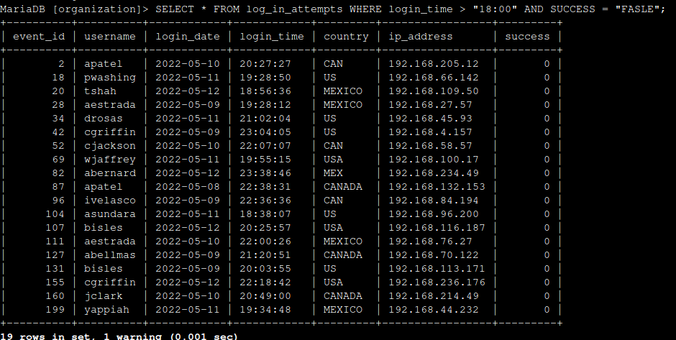

## Retrieve login attempts on specific dates

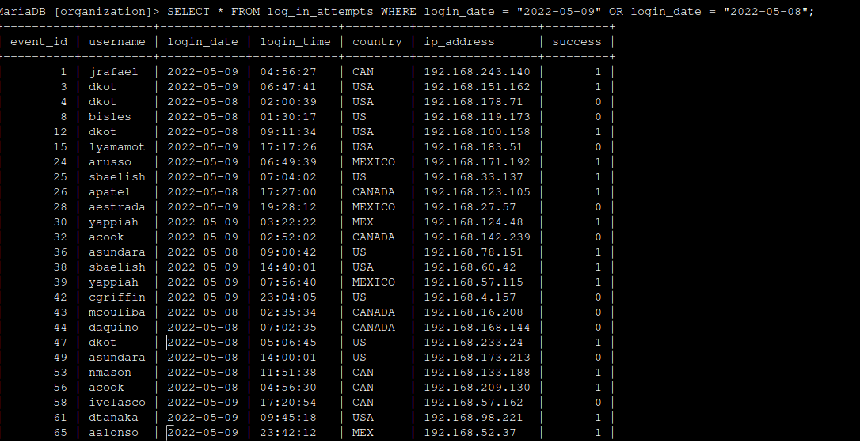

## Retrieve login attempts outside of Mexico

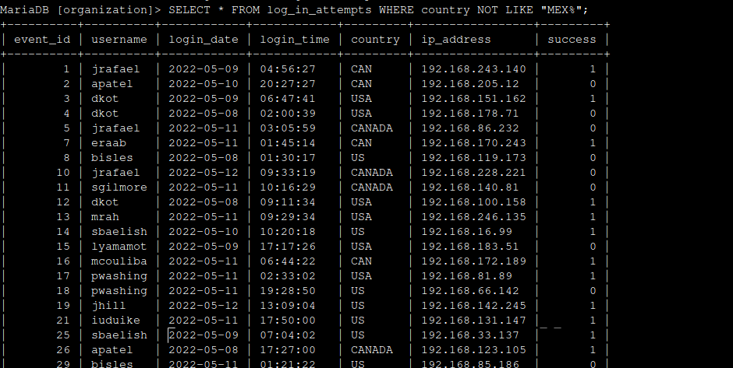

## Retrieve employees in Marketing

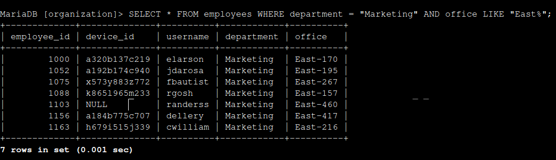

## Retrieve employees in Finance or Sales

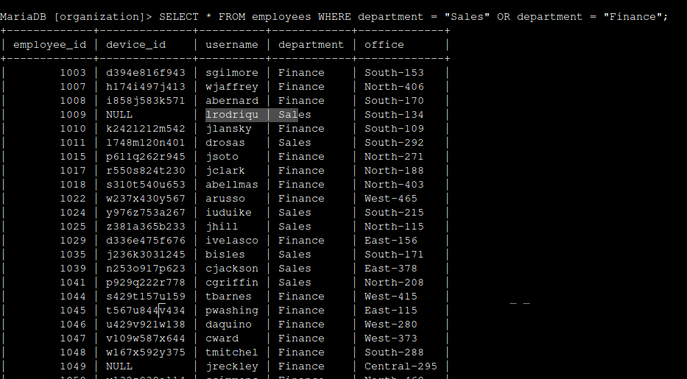

## Retrieve all employees not in IT

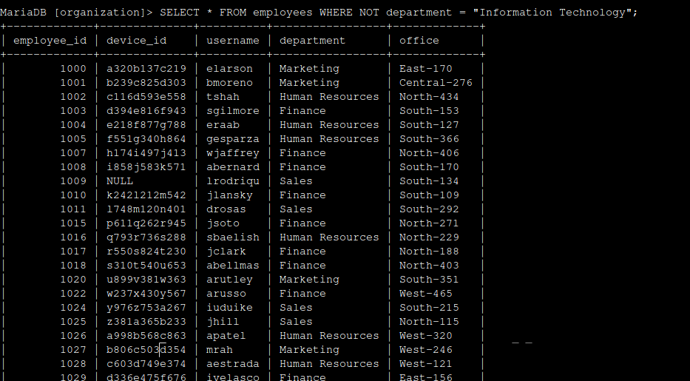

## Summary

[Add content here.]